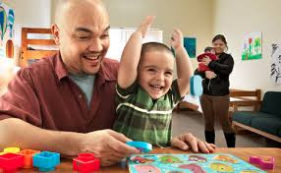
Children with Special Needs
A Support Group for Parents of Young Children

Parent support groups are a great place to meet others in similar situations. We invite you to participate in this free support group designed for parents and caregivers of children 0-5 years old to share their experiences, tools and learn from other parents about raising children/babies with disabilities and special needs. Learn how to keep you and your baby healthy and safe.
Where: Carolyn Kordich Family Resource Center
*Located at Volunteers of America
Head Start & Early Head Start*
Address: 1135 W.257th Street, Harbor City CA 90710

Next Meeting: Tuesday May 12th, 2015
*Meets the 2nd Tuesday of every month*

Time: 9:30-11:00am

Hosts: Dominique DeBorba and Edith Romero

**Snacks and Refreshments provided**
To register, or for more information contact:
Johanna Rubio at: 562-422-8472
-or-
Dominique DeBorba / Edith Romero at:
310-325-7288

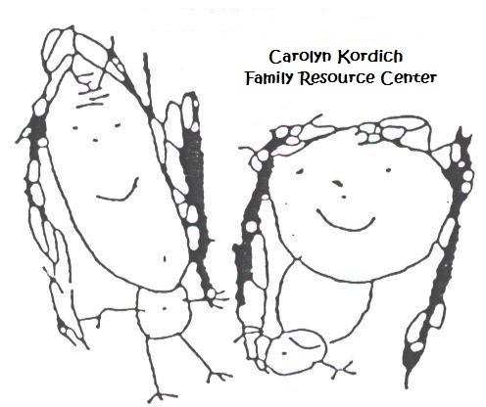
**Free Child Care is available. Registration is required.**

